**Experiment-No.1**

**Objective:** Installation of Python/Anaconda and introduction of Google Colab

| **Scheduled Date:** | **Compiled Date:** | **Submitted Date:** |
| --- | --- | --- |
| 11 Sep 2023 | 11 Sep 2023 | 17- Sep 2023 |

Anaconda is an open-source software that contains Jupyter, spyder, etc that are used for large data processing, data analytics, heavy scientific computing. Anaconda works for R and python programming language. Spyder(a sub-application of Anaconda) is used for python. Opencv for python will work in spyder. Package versions are managed by the package management system called conda.

**Download and install Anaconda:**

1. **Head over to anaconda.com and install the latest version of Anaconda.**

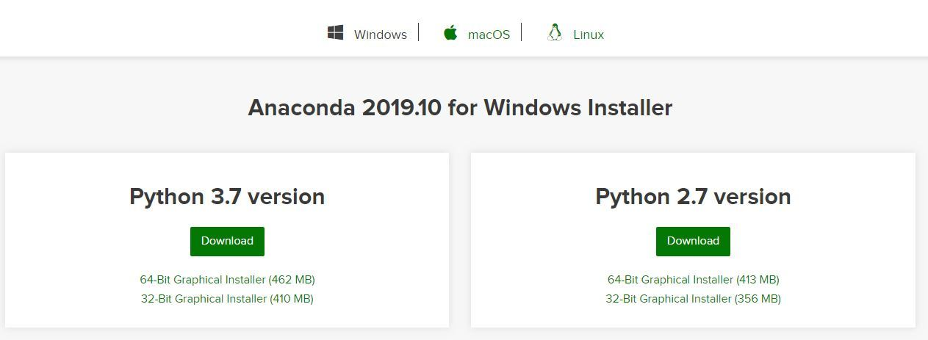

1. **Begin with the installation process:**

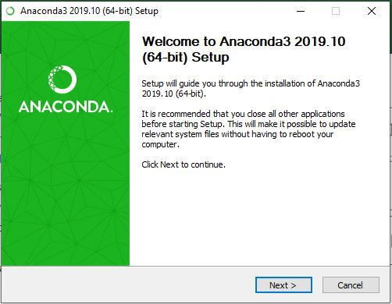

1. **Getting through the License Agreement:**

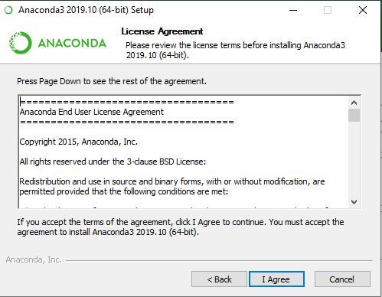

**4.Select Installation Type: Select Just Me if you want the software to be used by a single User**



**5. Choose Installation Location:**

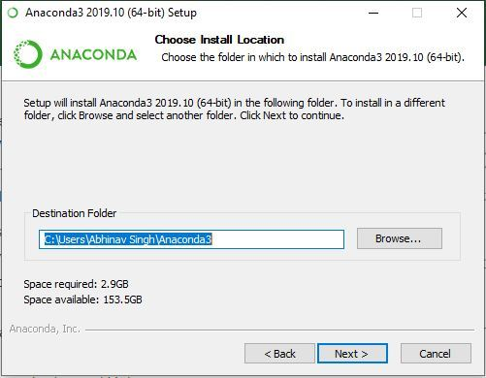

**6. Getting through the Installation Process:**

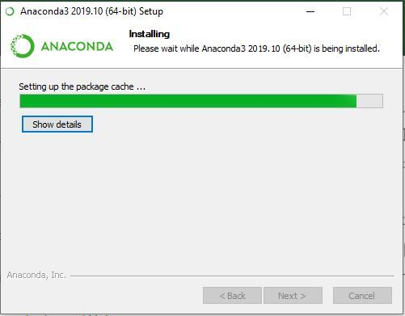

**7. Finishing up the Installation:**

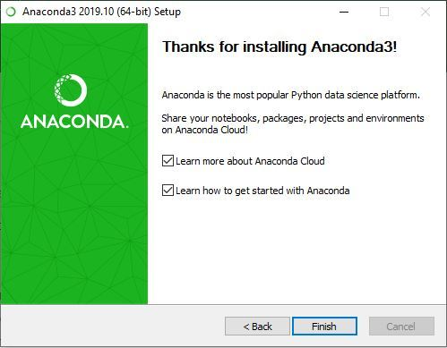

**Introduction of Google Colab**

Google Colab is a free Jupyter notebook environment that runs entirely in the cloud. Most importantly, it does not require a setup and the notebooks that you create can be simultaneously edited by your team members - just the way you edit documents in Google Docs. Colab supports many popular machine learning libraries which can be easily loaded in your notebook.

## What Colab Offers You?

As a programmer, you can perform the following using Google Colab.

* Write and execute code in Python
* Document your code that supports mathematical equations
* Create/Upload/Share notebooks
* Import/Save notebooks from/to Google Drive
* Import/Publish notebooks from GitHub
* Import external datasets e.g. from Kaggle
* Integrate PyTorch, TensorFlow, Keras, OpenCV
* Free Cloud service with free GPU